

https://www.thespruceeats.com/thmb/XqsPvgnFNDl1gu0Jl8z2iFHjYQY=/4928x3280/filters:no_upscale():max_bytes(150000):strip_icc()/south-african-potjiekos-in-black-pot-478688819-5ac23cf80e23d900368ed60f.jpg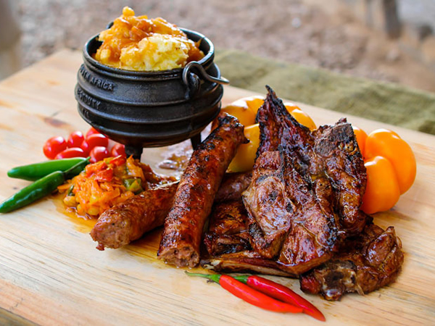

https://th.bing.com/th/id/R.57adc2b7ff64d5e1d6b58b845630e0b7?rik=YhK%2bqO4nlYxlhw&riu=http%3a%2f%2fhenristeenkamp.org%2fwp-content%2fuploads%2fhenristeenkamp-org%2fsites%2f28%2fbunny-chow.jpeg&ehk=ZqLWgRmWMFZK9XpAu57sD6cMZKnOrzbO5x9hzPQJYhI%3d&risl=&pid=ImgRaw&r=0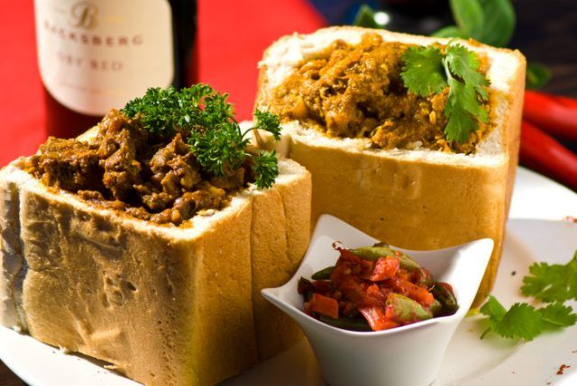

https://tse3.mm.bing.net/th/id/OIP.ihC0DrnTXCR-NC1H30m1igHaEO?r=0&rs=1&pid=ImgDetMain&o=7&rm=3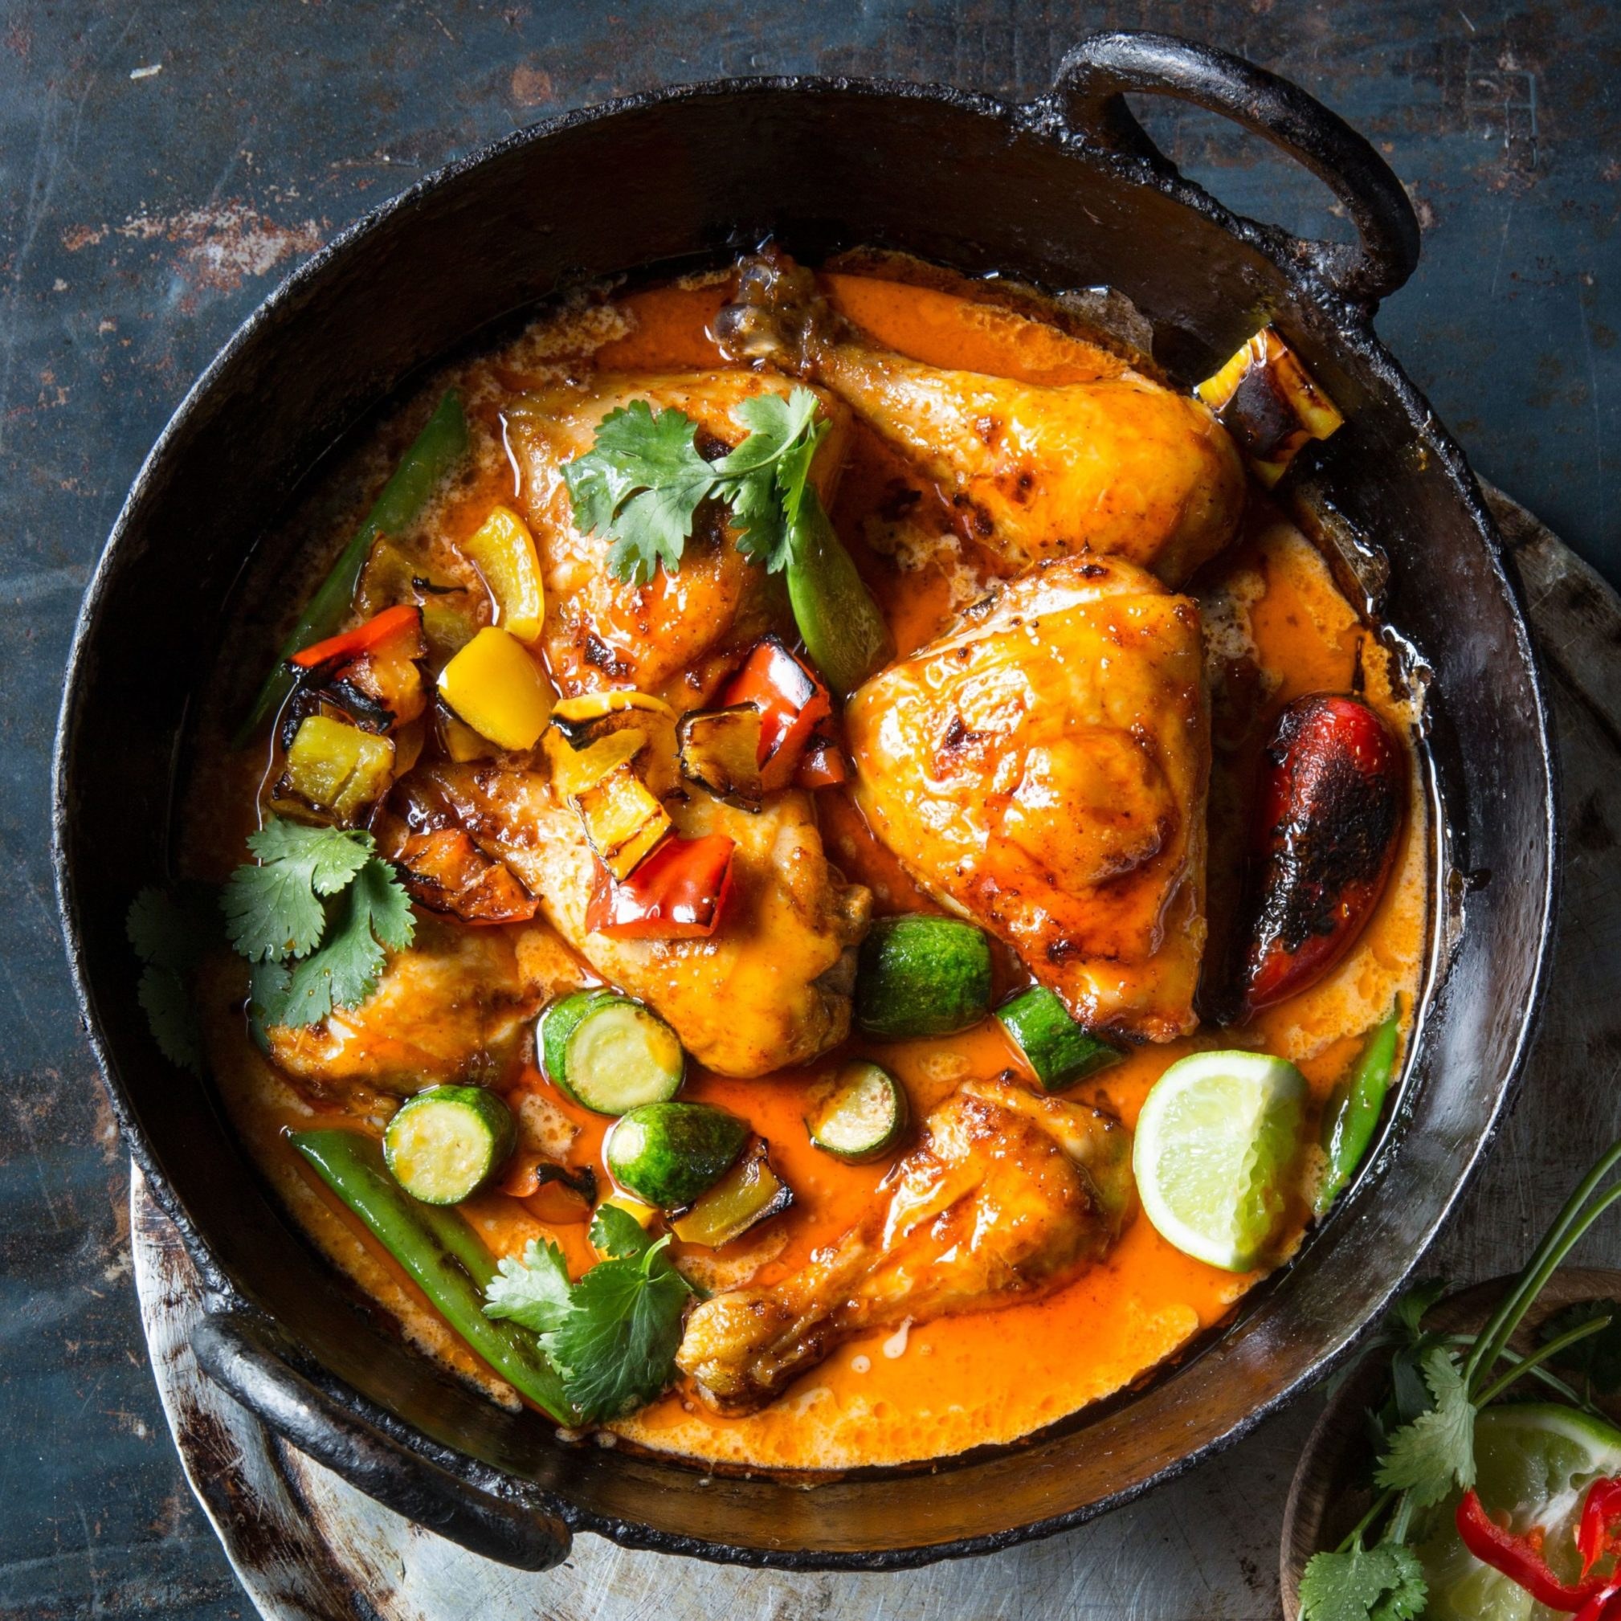

https://tse2.mm.bing.net/th/id/OIP.l1QPbeAYpEWkOnVp0fe-QwHaHa?r=0&rs=1&pid=ImgDetMain&o=7&rm=3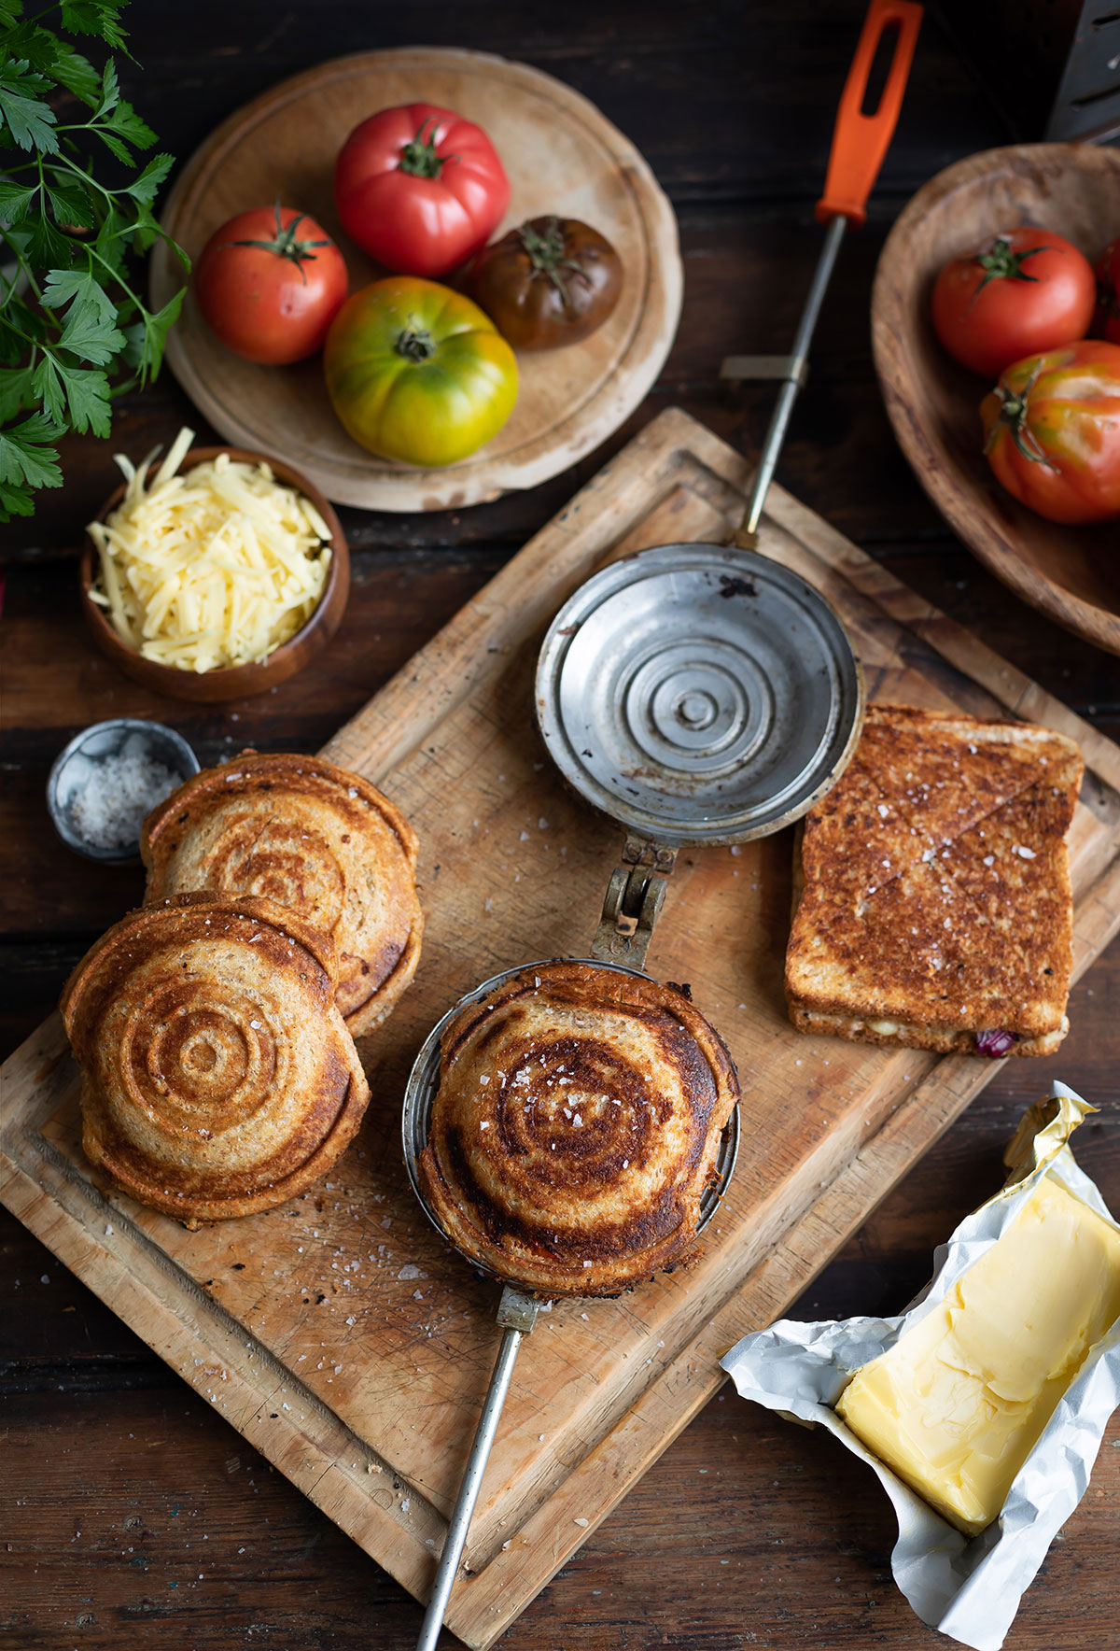

https://tse3.mm.bing.net/th/id/OIP.C4p2gSeCeSUQ9tXQ7JbRGwHaE8?r=0&rs=1&pid=ImgDetMain&o=7&rm=3
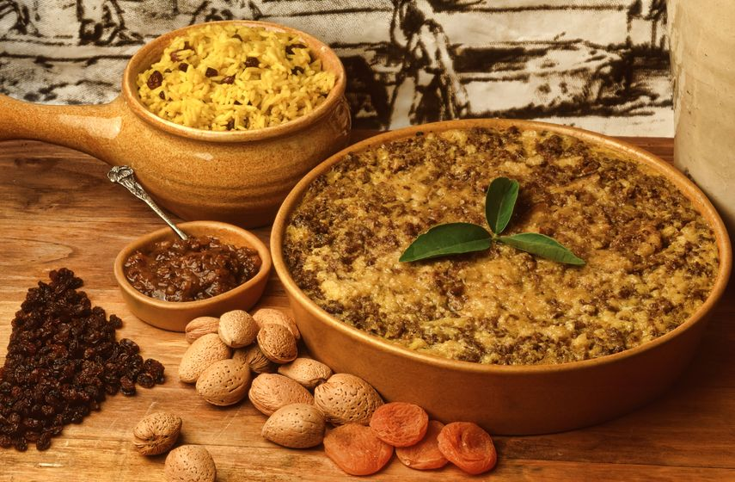

https://tse4.mm.bing.net/th/id/OIP.6W143s8JZUOJvge1puNnWAHaE5?r=0&rs=1&pid=ImgDetMain&o=7&rm=3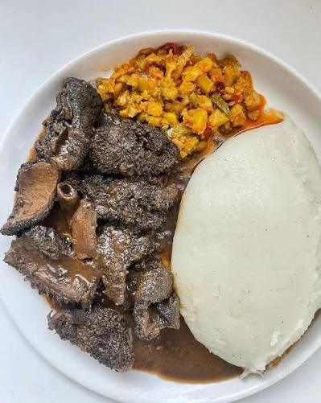

https://th.bing.com/th/id/R.243f8571a340be1de75b903f6fd9a436?rik=SMMMADHNgoOI2A&riu=http%3a%2f%2fsouthafricanshop.uk%2fcdn%2fshop%2farticles%2f1_3bc31e46-43b8-40d0-a511-c4c490d0c060_1200x1200.jpg%3fv%3d1713880324&ehk=L73W%2flY7H0i8djFAMF7ApWH%2bC016wL%2fTCiZ5BVI8LS8%3d&risl=&pid=ImgRaw&r=0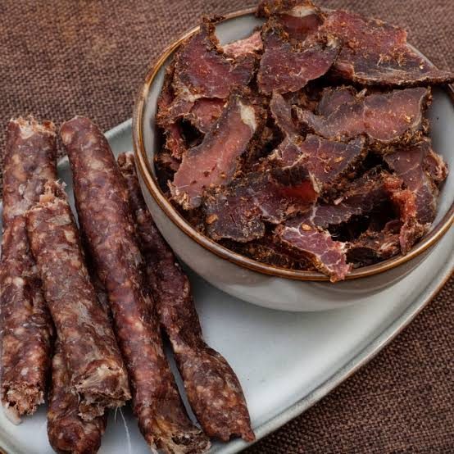

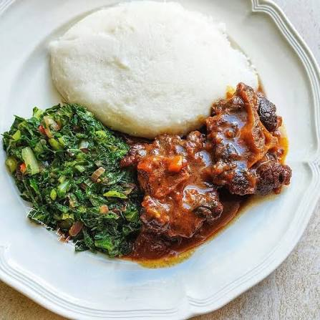
https://i.ytimg.com/vi/Stq0tzU3Yl8/oardefault.jpg?sqp=-oaymwEkCJUDENAFSFqQAgHyq4qpAxMIARUAAAAAJQAAyEI9AICiQ3gB&rs=AOn4CLDm0Nm0azX-T3m0uLNctgp4-oMXUg

https://andiswaskitchen.com/wp-content/uploads/2021/09/IMG_6320.jpg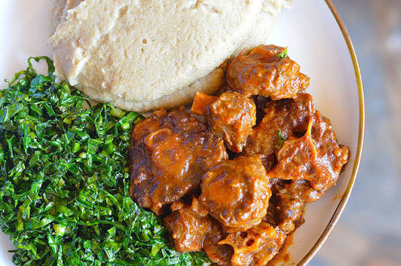
https://tse2.mm.bing.net/th/id/OIP.QUGp1sXR9wMeeGkuxks6MAHaEH?r=0&rs=1&pid=ImgDetMain&o=7&rm=3https://tse1.explicit.bing.net/th/id/OIP.QcycP4huyBAKRSYOb5V4jQHaLH?r=0&rs=1&pid=ImgDetMain&o=7&rm=3

